***PROJECCT REPORT***

INTRODUCTION

* OVERVIEW

Uber is a multinational transportation network company that offers ridesharig, foos delivery, and various other transportation services through its smartphone app.the company operates in many countries and cities worldwide, connecting rivers and riders while also exploring innovations in autonomous vehicles and other transportation technologies.

* PURPOSE

Uber’s primary purpose is to provide a convenient and efficient platform for individuals to request rides from drivers.

It connects passengers with drivers using a smartphone app, making transportation more accessible and flexible.

Uber aims to offer an alternative to traditional taxi services and promote ridesharing, which can help reduce congestion and provide income opportunities for drivers.

Uber has expanded into various other services like food delivery (Uber Eats) and freight logistics.

* ***PROBLEM DEFINITION & DESIGN THINNKING***

EMPATHY MAP:

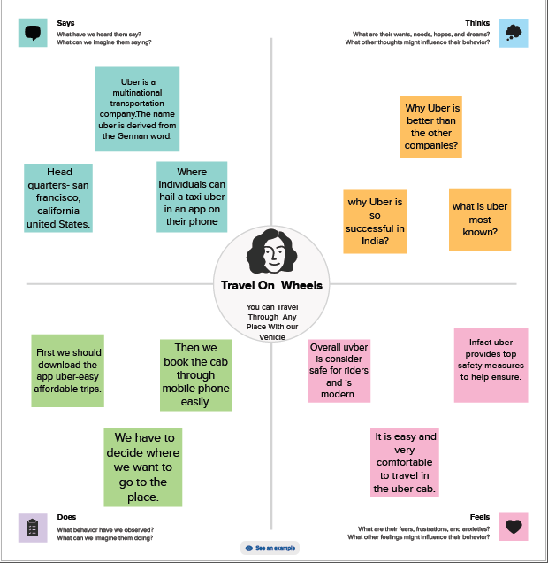

BRAIN STORMING MAP:

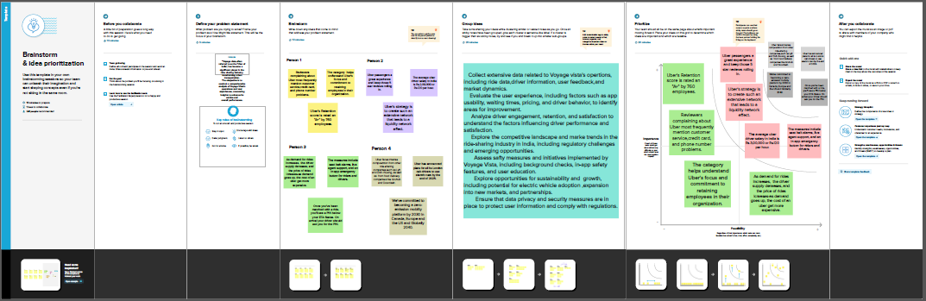

**RESULT**

* Screenshots:
* ***Dashboard 1***

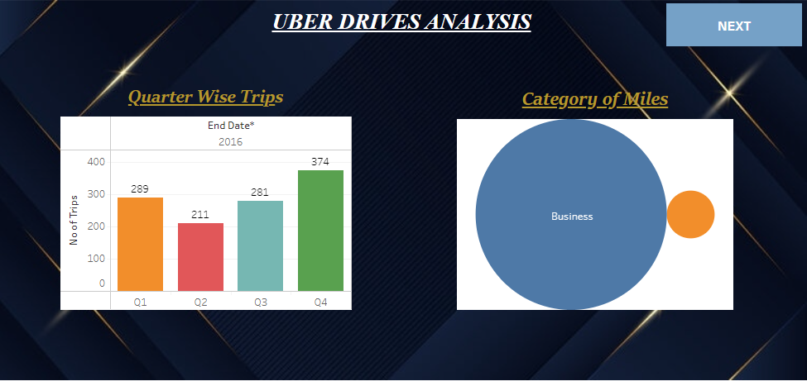

* ***Dashboard 2***

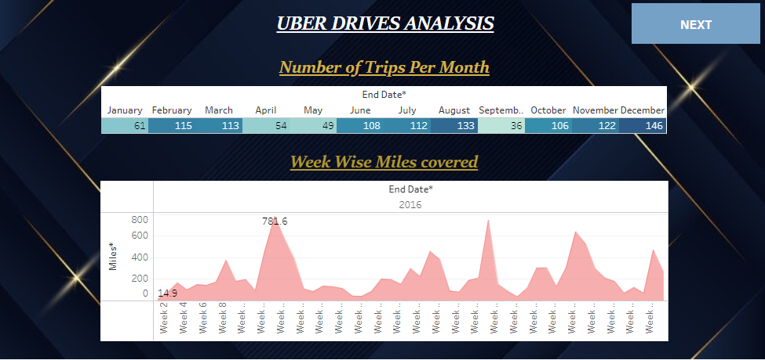

* 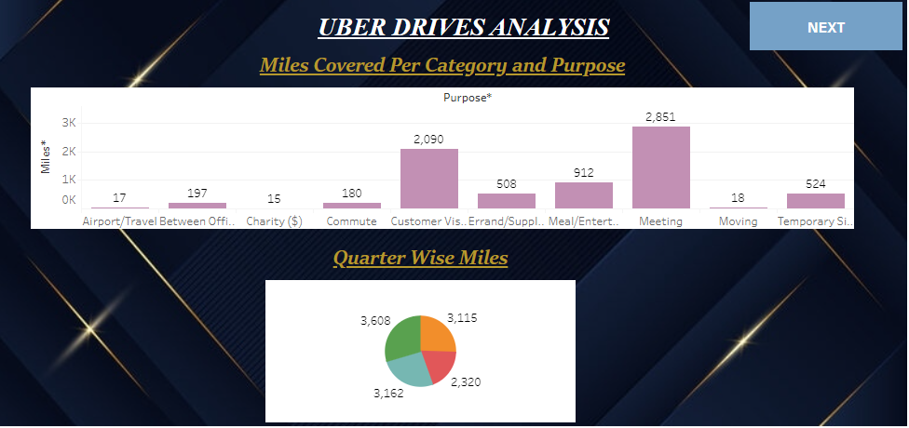***Dashboard 3***



* ***Dashboard 4***

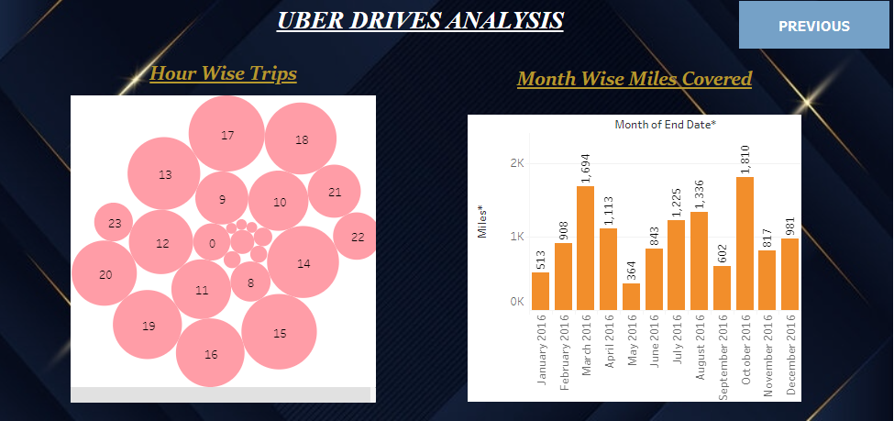

***STORY***

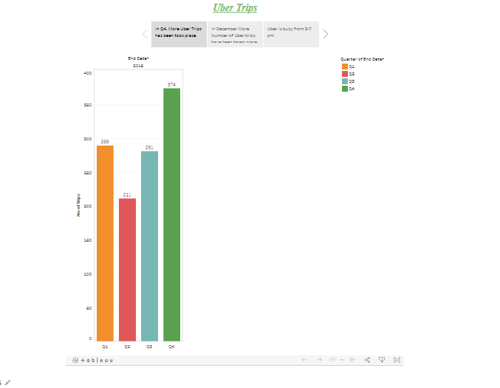

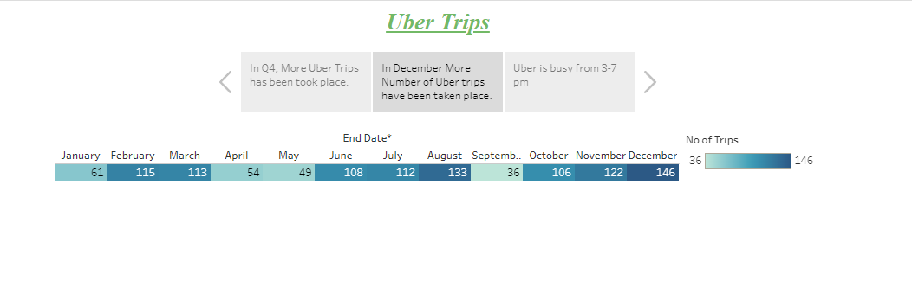

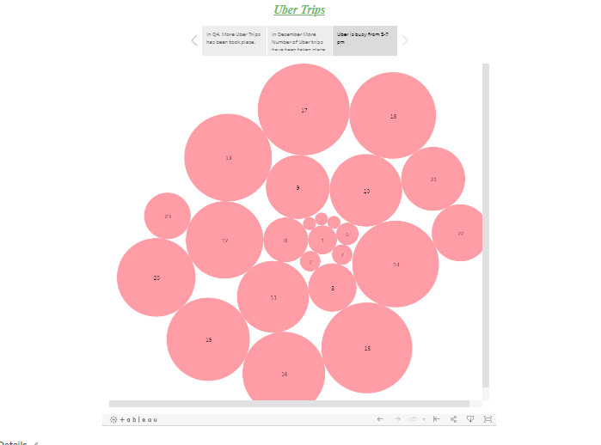

* ADVANTAGES & DISADVANTAGES

Uber provides a convenient way to book a ride with just a few stteps on a smartphone. You can request a ride from almost annywhere. Uber rides can be more affordable than traditional taxis in many cases, especially for shorter trips. Uber has safety fetures such as rel-time GPS trackimg, driver and passenger ratings, and shareable trip details, which can enhance passenger safety. Uber offers options like UberPool, which allows passengerrs to share rides and reduce costs.

During high_demand times, Uber may implement urge pricing, which can significantly increase the cost of a ride. While there are many excellent Uber drivers, the quality of seeervice cn vary, and some driverrsmay not meet your expetations .

APPLICATIONS

Uber is a popular ride-sharing and transportation service. Its mobile application allows userss to request rides, track drivers, and make payments. You can download the Uber app from your device’s app store sign up for an account, and start using it to book rides or other services like Uber Eatss for food dellivery. Is therre something specific you’d like to know about the Uber app or any particular feature you have in mind?

FUTURE SCOPES:

* + Given the increasing focus on environmental concerns, Uber might invest in electric or hybrid vehicle fleets to reduce emissions.
  + Uber could integrate more closely with publlic transportation systems to provide seamless, multi-modal transportaion options.

**CONCLUSION**

Uber is a gloabal transportaion and ride-sharing company that has disrupted the traitional taxi industry. Its mobile application allows users to request rides, track drivers, and make payments. Over the years, Uber has expanded itss services to include food dellivery(Uber Eats) and logistics (Uber Freight).